Assigement-10(Nov 21-11-2018)

1. WAJP to find rate of interest of icici,sbi,Andhra,city using the concept of run time polymorphism

Program:

**class** Bank1

{

**void** bankData()

{

System.***out***.println("Every Bank has Interest");

}

}

**class** Icici **extends** Bank1

{

**void** bankData()

{

System.***out***.println("Rate Of Interset of Icici Bank is :18%");

}

}

**class** Sbi **extends** Bank1

{

**void** bankData()

{

System.***out***.println("Rate Of Interset of Sbi Bank is :20%");

}

}

**class** Andhra **extends** Bank1

{

**void** bankData()

{

System.***out***.println("Rate Of Interset of Andhra Bank is:24%");

}

}

**class** City **extends** Bank1

{

**void** bankData()

{

System.***out***.println("Rate Of Interset of City Bank is :13.5%");

}

}

**public** **class** Bank {

**public** **static** **void** main(String[] args) {

Bank1 obj;

obj=**new** Icici();

obj.bankData();

obj=**new** Sbi();

obj.bankData();

obj=**new** Andhra();

obj.bankData();

obj=**new** City();

obj.bankData();

}

}

Output:

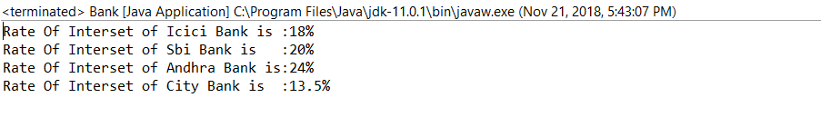

1. WAJP to find the area of square,rectangle using method over loading

Program:

**class** Area

{

**int** a,b;

**void** area(**int** a)

{

**int** area=a*a;

System.***out***.println("Area of Square:"+area);

}

**void** area(**int** a,**int** b)

{

**int** area=a*b;

System.***out***.println("Area of Rectangle:"+area);

}

}

**public** **class** MethodOverLoading {

**public** **static** **void** main(String[] args) {

Area obj=**new** Area();

obj.area(2,89);

obj.area(2);

}

}

Output:

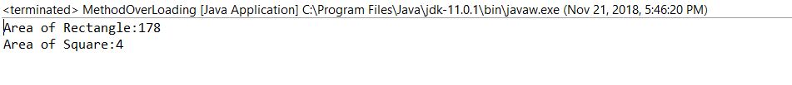

1. WAJP to test overloading of main method test

Program:

**public** **class** TestOverLoad {

**public** **static** **void** main(String[] args) {

System.***out***.println("Karimulla is a good boy");

*main*(**null**,**null**);

}

**public** **static** **void** main(String args[],String[] arg)

{

System.***out***.println("I am King");

}

}

Output:

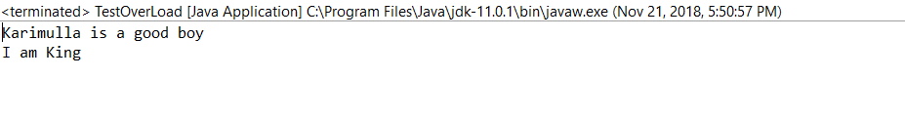

1. WAJP to calculate no of character no of white spaces,no of words of the following statement
2. Java is object oriented programming language developed by James Gosling

Program:

**public** **class** Calculate {

**public** **static** **void** main(String[] args) {

String s="Java is object oriented programming language developed by James gosling";

String s1[]=s.split(" ");

String s2[]=s.split("");

**int** c1=0;

**int** c2=0;

**for** (**int** i1 = 0; i1 < s1.length; i1++) {

c1++;

}

**for** (**int** j1 = 0; j1 < s2.length; j1++) {

c2++;

}

System.***out***.println("No Of Words :"+c1);

System.***out***.println("No Of Characters: "+c2);

System.***out***.println("No Of White spaces:"+(c1-1));

}

}

Output:

